|  |  |
| --- | --- |
| **Logo_Baru-Rasmi_UUM_02** | STIJ3074: WEB PROGRAMMING Semester A201School of Computing, CAS, UUM |
| PSet Lab 1 | |
| Date given: **28/10/2020 8.40 AM**  Submission date :**28/10/2020 10.20 AM** | |

Instructions:

1. Register a Github account under your name – Screenshot your main Github page

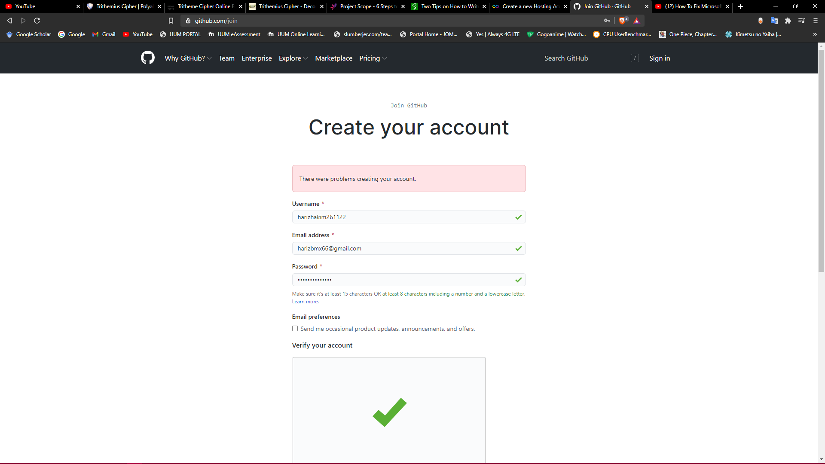

1. Download and install Github Desktop and login using your Github account. Screenshot Git GUI

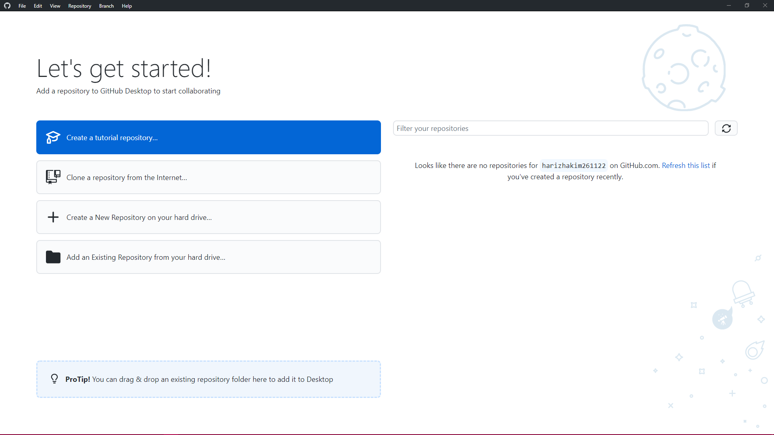

1. Create a project folder called stij3074 in your computer directory – Screenshot this folder

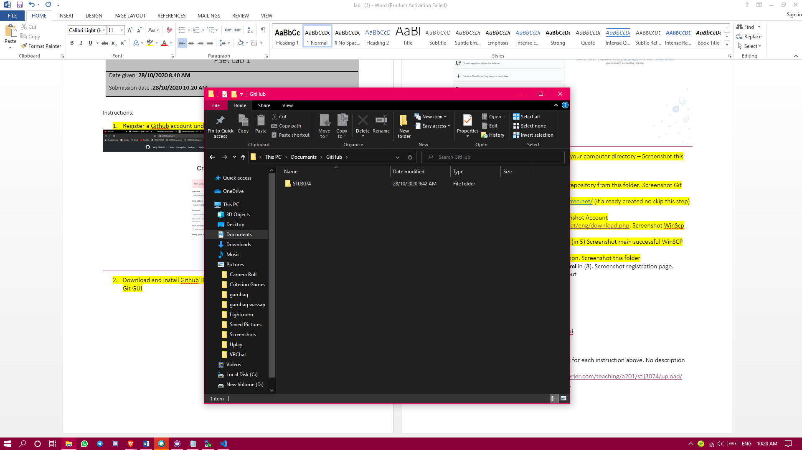

1. Git Gui from folder in (3) and create Git repository from this folder. Screenshot Git GUI create repository

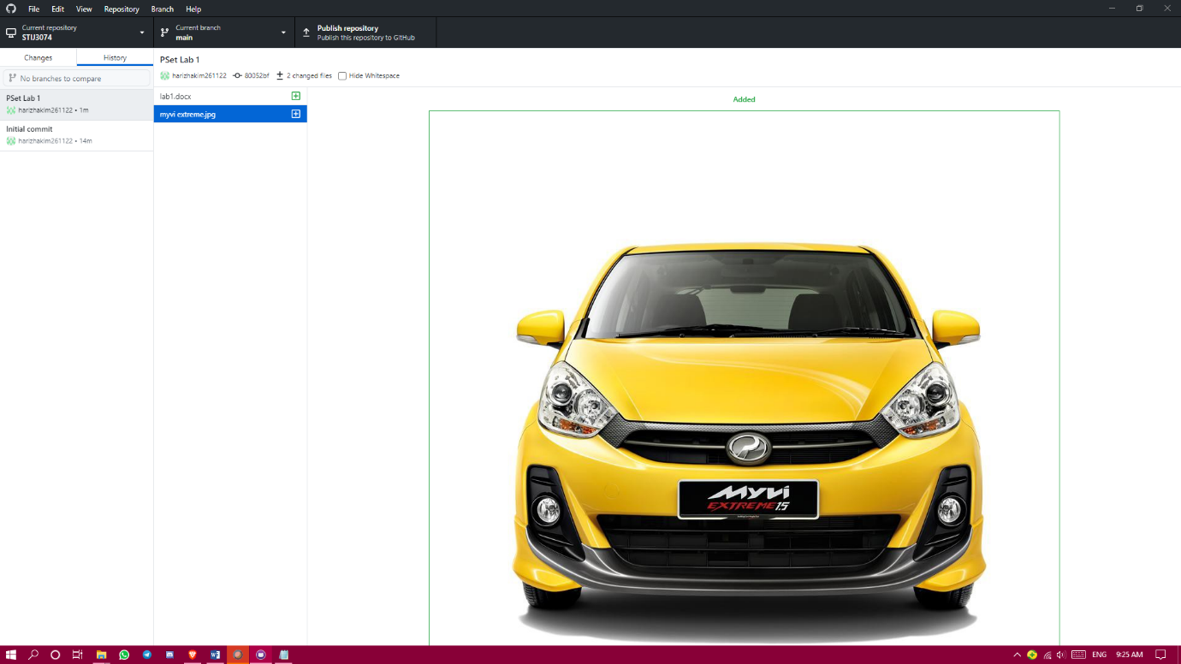

1. Create new account with <https://infinityfree.net/> (if already created no skip this step) Screenshot main cpanel

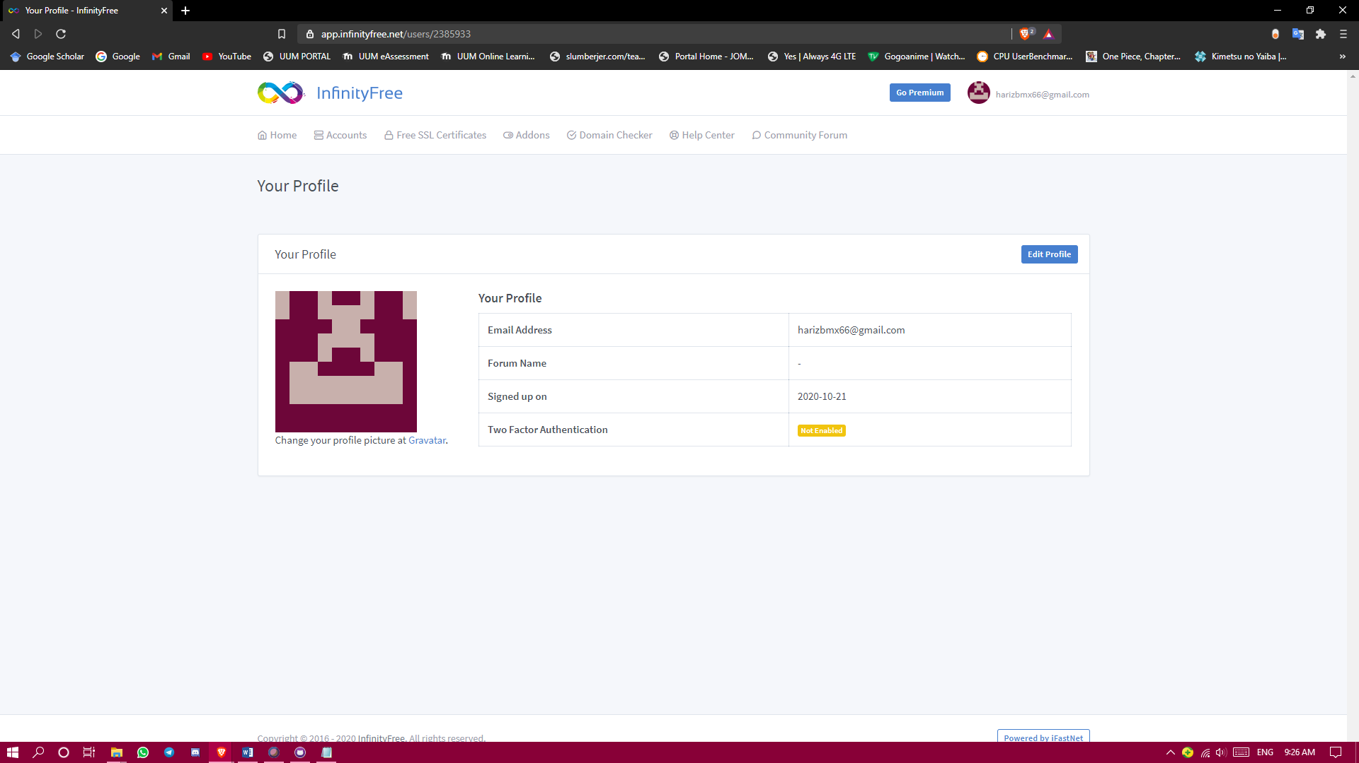

1. Create new account in client area. Screenshot Account

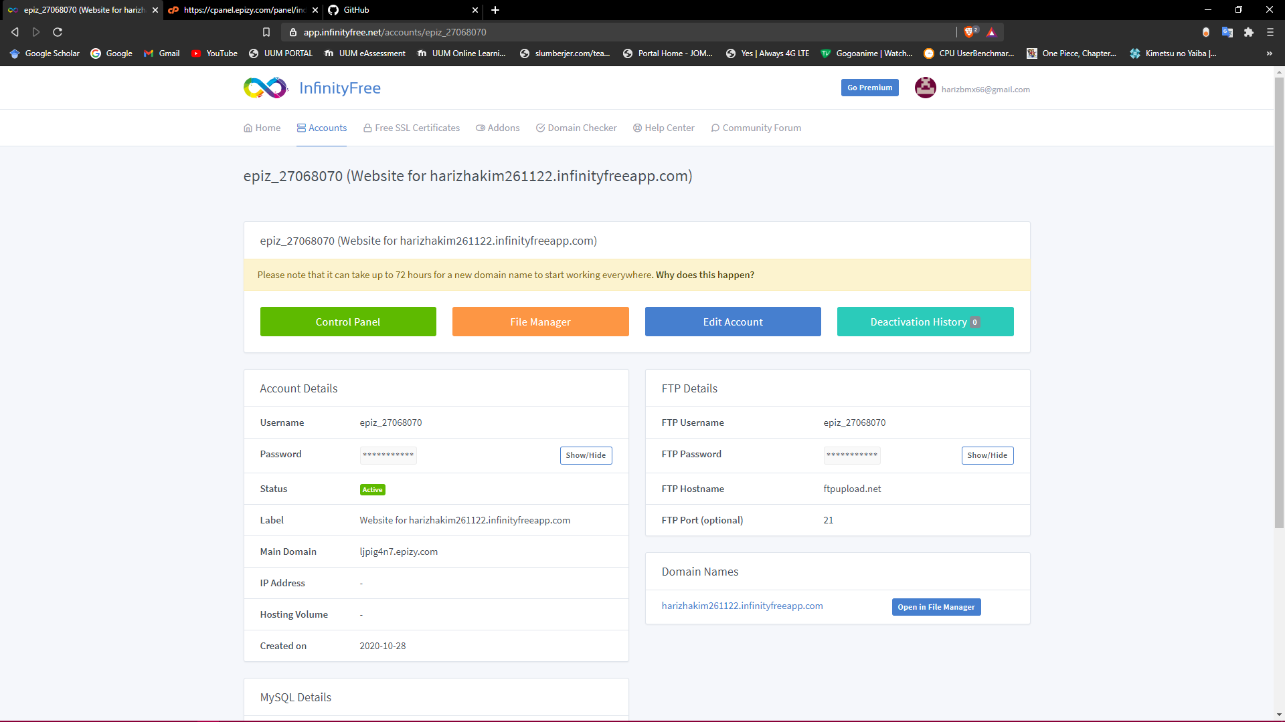

1. Download WinScp from <https://winscp.net/eng/download.php>. Screenshot WinScp main interface.

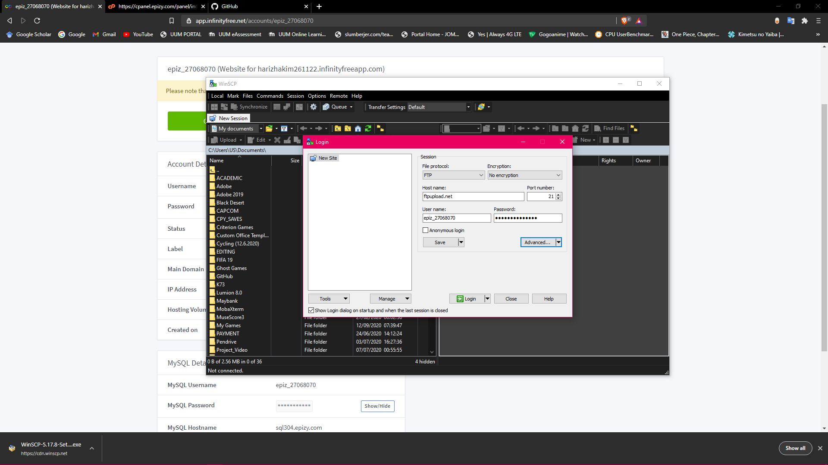

1. Connect your WinSCP FTP to your server (in 5) Screenshot main successful WinSCP interface

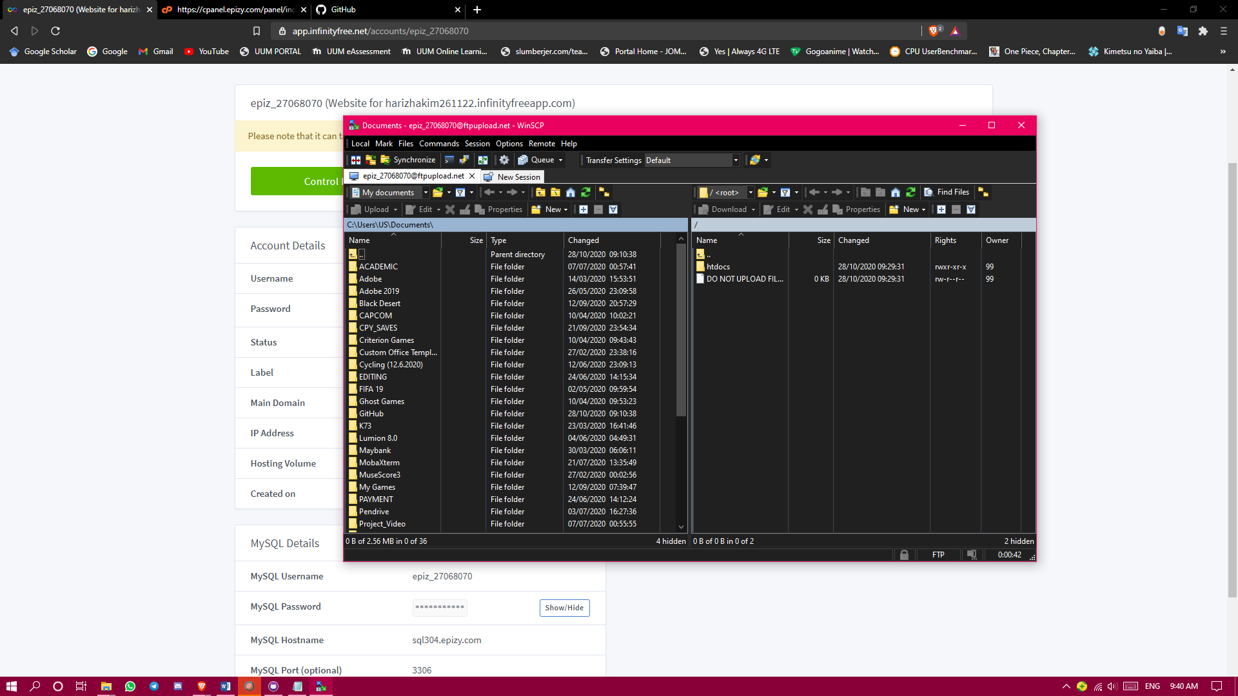

1. Create new folder in stij307 call registration. Screenshot this folder

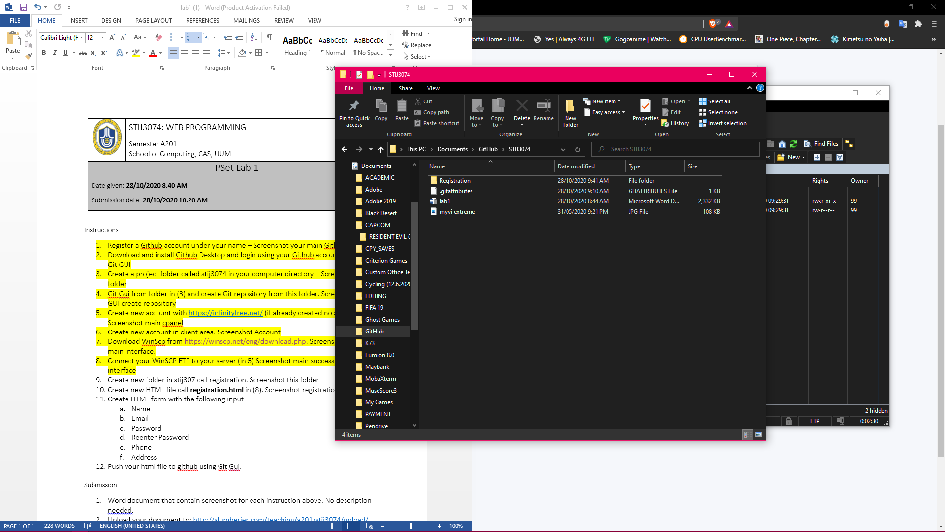

1. Create new HTML file call **registration.html** in (8). Screenshot registration page.

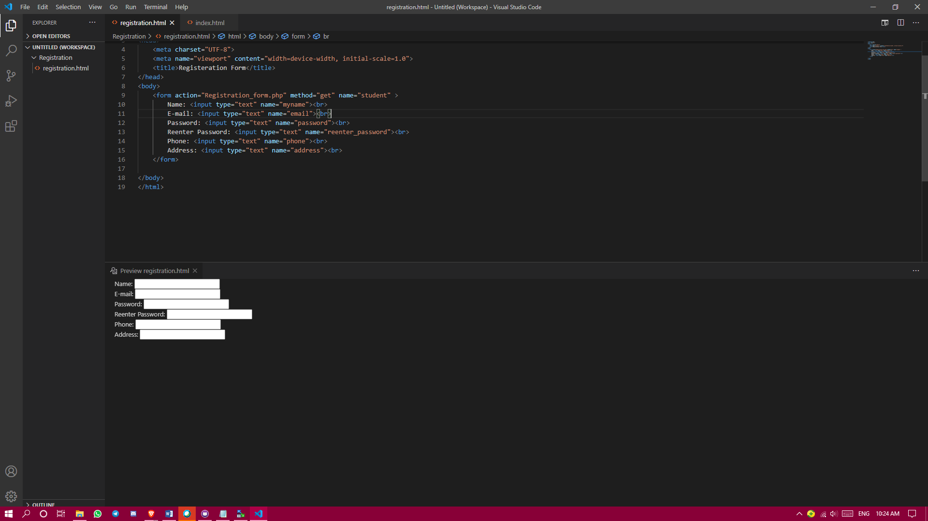

1. Create HTML form with the following input
   1. Name
   2. Email
   3. Password
   4. Reenter Password
   5. Phone
   6. Address

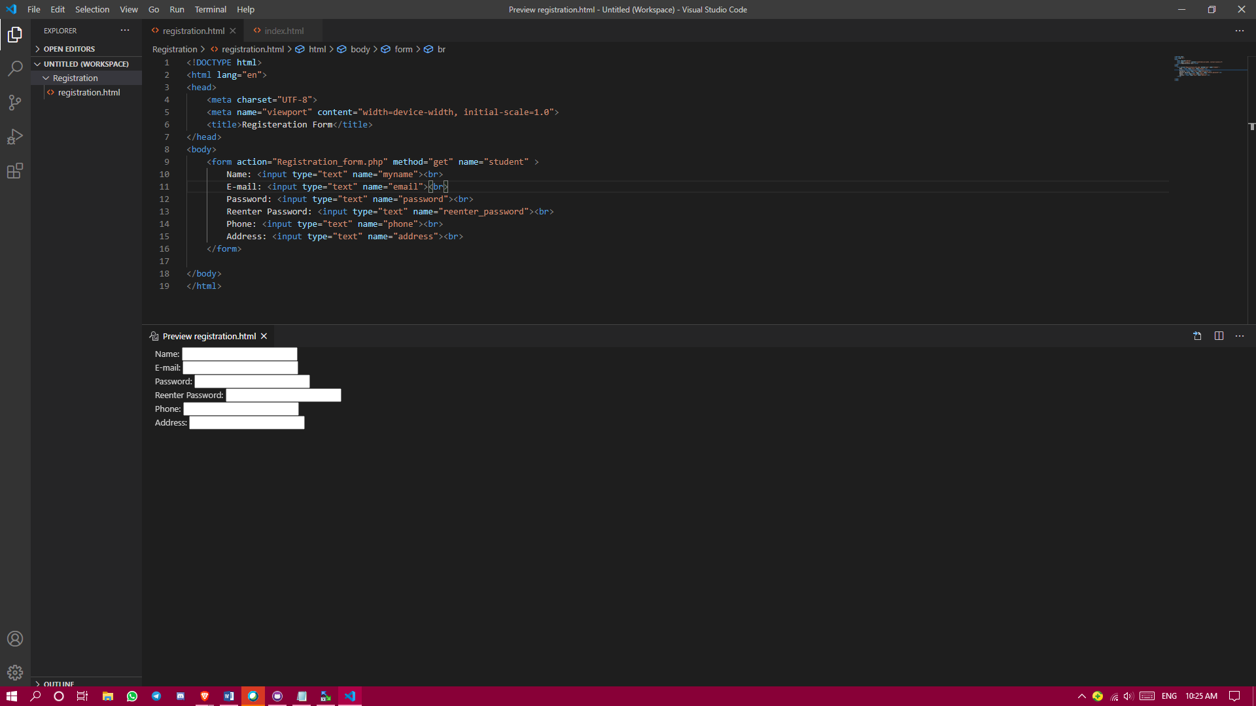

1. Push your html file to github using Git Gui.

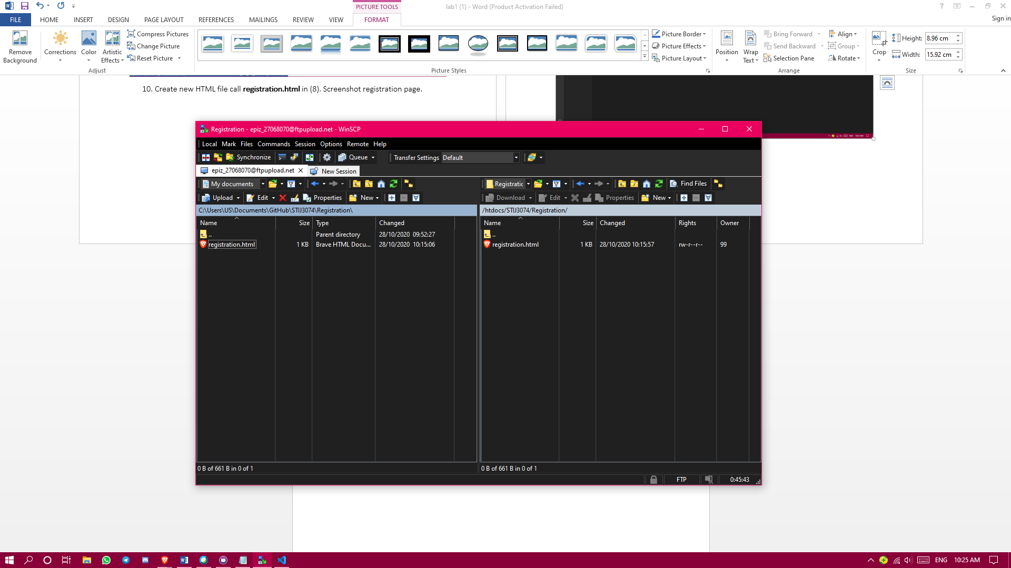

Submission:

1. Word document that contain screenshot for each instruction above. No description needed.
2. Upload your document to: <http://slumberjer.com/teaching/a201/stij3074/upload/>

Fill all the required information correctly.

**Late submission will be not accepted and will not be tolerated and given 0.**